|  |
| --- |
| Experiment No. 9 |
| Implement Non-Restoring algorithm using c-programming |
| Name: Harsh Tripathi |
| Roll Number: 59 |
| Date of Performance: |
| Date of Submission: |

**Aim -** To implement Non-Restoring division algorithm using c-programming.

**Objective -**

1. To understand the working of Non-Restoring division algorithm.
2. To understand how to implement Non-Restoring division algorithm using c-programming.

**Theory:**

In each cycle content of the register, A is first shifted and then the divisor is added or subtracted with the content of register A depending upon the sign of A. In this, there is no need of restoring, but if the remainder is negative then there is a need of restoring the remainder. This is the faster algorithm of division.

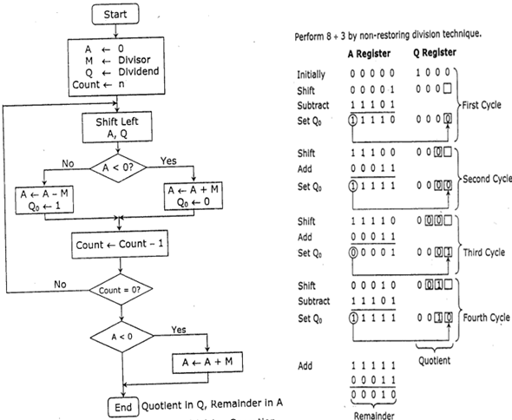

Program -

#include <stdio.h>

#include <stdlib.h>

int dec_bin(int, int []);

int twos(int [], int []);

int left(int [], int []);

int add(int [], int []);

int main()

{

int a, b, m[4]={0,0,0,0}, q[4]={0,0,0,0}, acc[4]={0,0,0,0}, m2[4], i, n=4;

printf("Enter the Dividend: ");

scanf("%d", &a);

printf("Enter the Divisor: ");

scanf("%d", &b);

dec_bin(a, q);

dec_bin(b, m);

twos(m, m2);

printf("\nA\tQ\tComments\n");

for(i=3; i>=0; i--)

{

printf("%d", acc[i]);

}

printf("\t");

for(i=3; i>=0; i--)

{

printf("%d", q[i]);

}

printf("\tStart\n");

while(n>0)

{

left(acc, q);

for(i=3; i>=0; i--)

{

printf("%d", acc[i]);

}

printf("\t");

for(i=3; i>=1; i--)

{

printf("%d", q[i]);

}

printf("_\tLeft Shift A,Q\n");

add(acc, m2);

for(i=3; i>=0; i--)

{

printf("%d", acc[i]);

}

printf("\t");

for(i=3; i>=1; i--)

{

printf("%d", q[i]);

}

printf("_\tA=A-M\n");

if(acc[3]==0)

{

q[0]=1;

for(i=3; i>=0; i--)

{

printf("%d", acc[i]);

}

printf("\t");

for(i=3; i>=0; i--)

{

printf("%d", q[i]);

}

printf("\tQo=1\n");

}

else

{

q[0]=0;

add(acc, m);

for(i=3; i>=0; i--)

{

printf("%d", acc[i]);

}

printf("\t");

for(i=3; i>=0; i--)

{

printf("%d", q[i]);

}

printf("\tQo=0; A=A+M\n");

}

n--;

}

printf("\nQuotient = ");

for(i=3; i>=0; i--)

{

printf("%d", q[i]);

}

printf("\tRemainder = ");

for(i=3; i>=0; i--)

{

printf("%d", acc[i]);

}

printf("\n");

return 0;

}

int dec_bin(int d, int m[])

{

int b=0, i=0;

for(i=0; i<4; i++)

{

m[i]=d%2;

d=d/2;

}

return 0;

}

int twos(int m[], int m2[])

{

int i, m1[4];

for(i=0; i<4; i++)

{

if(m[i]==0)

{

m1[i]=1;

}

else

{

m1[i]=0;

}

}

for(i=0; i<4; i++)

{

m2[i]=m1[i];

}

if(m2[0]==0)

{

m2[0]=1;

}

else

{

m2[0]=0;

if(m2[1]==0)

{

m2[1]=1;

}

else

{

m2[1]=0;

if(m2[2]==0)

{

m2[2]=1;

}

else

{

m2[2]=0;

if(m2[3]==0)

{

m2[3]=1;

}

else

{

m2[3]=0;

}

}

}

}

return 0;

}

int left(int acc[], int q[])

{

int i;

for(i=3; i>0; i--)

{

acc[i]=acc[i-1];

}

acc[0]=q[3];

for(i=3; i>0; i--)

{

q[i]=q[i-1];

}

}

int add(int acc[], int m[])

{

int i, carry=0;

for(i=0; i<4; i++)

{

if(acc[i]+m[i]+carry==0)

{

acc[i]=0;

carry=0;

}

else if(acc[i]+m[i]+carry==1)

{

acc[i]=1;

carry=0;

}

else if(acc[i]+m[i]+carry==2)

{

acc[i]=0;

carry=1;

}

else if(acc[i]+m[i]+carry==3)

{

acc[i]=1;

carry=1;

}

}

return 0;

}

**Output:**

Enter the Dividend: 10

Enter the Divisor: 2

A Q Comments

0000 1010 Start

0001 010_ Left Shift A,Q

1111 010_ A=A-M

0001 0100 Qo=0; A=A+M

0010 100_ Left Shift A,Q

0000 100_ A=A-M

0000 1001 Qo=1

0001 001_ Left Shift A,Q

1111 001_ A=A-M

0001 0010 Qo=0; A=A+M

0010 010_ Left Shift A,Q

0000 010_ A=A-M

0000 0101 Qo=1

Quotient = 0101 Remainder = 0000

**Conclusion -**

In conclusion, the Non-Restoring division algorithm serves as an efficient method for performing division operations in computer programming. Through the implementation of this algorithm using the C programming language, we have explored a robust approach to dividing numbers that minimizes the number of iterations required and optimizes computational efficiency. By carefully designing the algorithm and writing a C program that incorporates it, we have demonstrated the practicality and effectiveness of this approach in performing complex mathematical operations. The successful execution of this project underscores the significance of algorithmic efficiency in enhancing the performance of computational tasks, paving the way for further advancements and applications in the field of computer science and software development.